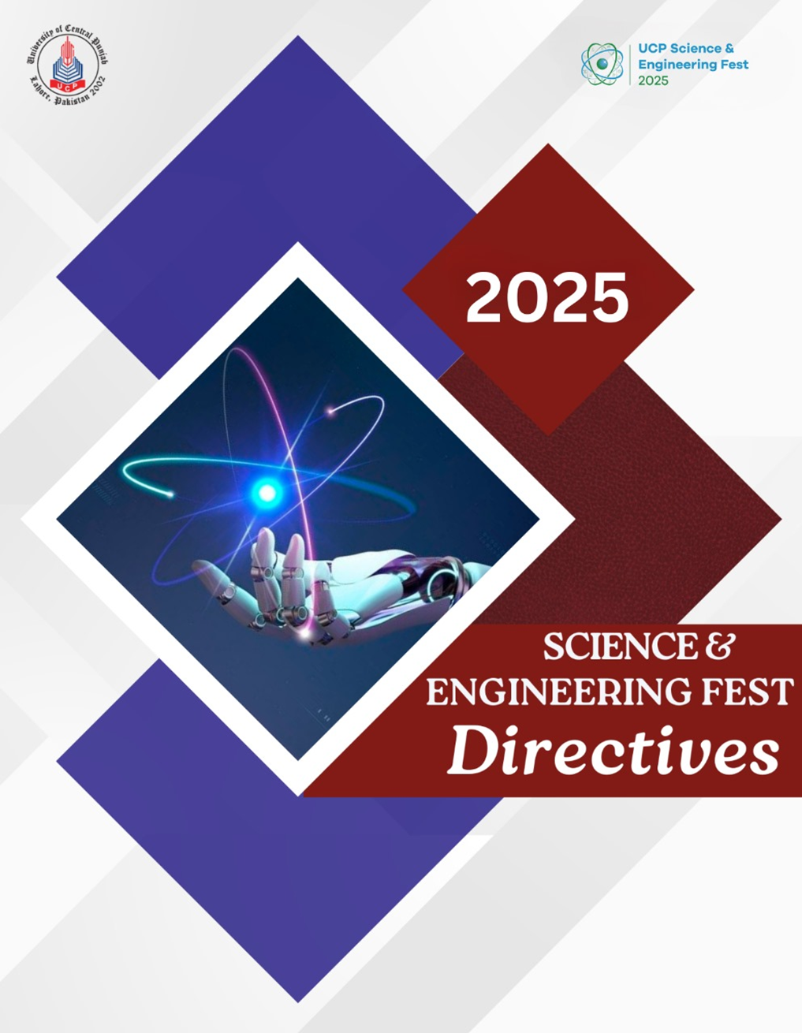

**Science & Engineering FEST**

**Directives 2025**

Submitted By:

Faculty of Engineering (FOE)

Faculty of Science and Technology (FOST)

Contents

Overview 5

Theme of the year 5

Format 6

MODULES 7

1. Competitive Module 8

1.1 Brain Fest 8

1.2 3D-Model Competition 9

1.3. Poster Competition 11

1.4. The Green Equation Expedition (Math Treasure Hunt) 14

1.5. Pet Show Competition 16

1.6. Egg drop……………….…………………………………………………………………………..19

2. Workshop Modules 21

2.1 Microbial Culture Art Workshop & Competition 20

2.2 3D Printing and Modelling 22

2.3 Robotics 22

2.3.1 Line Follower 22

2.3.2 RC Car/Maze Solver………………….…………………………………………………………26

2.4 Truss Bridge Competition 25

3. Exhibition and Shows 26

3.1 Science Cinema 26

3.2 Science Circus 27

3.3 Nutrition camp 28

3.4 Animal Taxidermy 29

3.5 Departmental Projects Display 29

4. Fun and Games 31

4.1 Jenga Jam 31

4.2 Brain Games 32

4.2.1 Mensa Connections/Ingenious 32

4.2.2 Rummy O-Rule 33

4.2.3 Chinese checker 34

4.4 Human Ludo 35

Summary 36

# Overview

The Faculty of Engineering (FOE) and Faculty of Science and Technology (FOST) are organizing an event by the title of “Science and Engineering Fest 2025” as join hosts.

This event will be held among students at different colleges and universities to provide students of University, intermediate, and A-levels a space to test and showcase their theoretical knowledge and their proficiency in its application in competitive environments. This will be a two-day event starting on January 21st, 2025, and will end on January 22nd 2025. There will be different competitions falling into four categories namely the Competitive module, Workshop Module, Exhibition Modules, and fun and games.

# Theme of the year

**Sustainable Environment – Science for a Better Tomorrow**

This year’s theme, "Sustainable Environment: Science for a Better Tomorrow," places a strong emphasis on the critical role that scientific innovation and engineering play in tackling the environmental challenges we face today. As the world grapples with issues like climate change, resource depletion, pollution, and biodiversity loss, the festival seeks to highlight how scientific and technological advancements can provide sustainable solutions for a healthier planet.

The theme encourages participants to explore the intersection of sustainability and innovation, demonstrating how scientific knowledge can be applied to create practical, eco-friendly solutions in various fields. From renewable energy technologies to green engineering practices, the festival will focus on showcasing projects and ideas that contribute to a more sustainable and resilient future.

Through this theme, the festival aims to foster a deeper understanding of the urgent need for sustainable development in all sectors, whether it’s through energy-efficient designs, waste reduction strategies, or the development of technologies that minimize our ecological footprint. By engaging students, educators, and professionals, the event will provide a platform to discuss how science and engineering can directly contribute to solving environmental issues and ensuring a better, more sustainable tomorrow for future generations.

# Format

**Competitions:**

Intermediate and undergraduate level students will be pitched for various competitions to enhance their skills and knowledge based upon the current demands of academia and industry. A schedule of competitions will be issued according to the registrations.

**Workshops:**

To give some basic knowledge and guidance to college students, a set of workshops will be arranged. These workshops will help them build their engineering-related projects for the main event. The workshops will be planned one week before the main event. A schedule of workshops will be issued according to the registrations.

**Exhibitions:**

To promote the quest for science and technology among freshmen and sophomores an exhibit of the scientifically intriguing and engaging showcase of creative ideas will be held on two days event. The schedule of the event will be issued according to registrations.

**Fun and Games:**

Basic recreational and fun activities will be planned to ensure the interest and involvement of the audience keeping the scientific and Engineering grounds in perspective.

**Events:**

|  |  |
| --- | --- |
| Day | Date |
| Day 1 | 21st January 2025 |
| Day 2 | 22nd January 2025 |

The main event of Science and Engineering FEST 2025 is scheduled to be held as per the following:

**Note:** The above schedule is tentative and is subject to changes.

# Modules

|  |  |  |
| --- | --- | --- |
| Sr. No | Module | Event |
| 1 | Competitive Module | Brain FEST |
| 2 | 3D Model and Project Display |
| 3 | Poster Competition |
| 4 | Green-Equation Expedition (Math Treasure Hunt) |
| 5 | Pet Contest |
| 6 | Egg Drop Competition |
| 1 | Workshop Module | Microbial Culture Art |
| 2 | 3D Modeling and Printing |
| 3 | Robotics (Line Follower) |
| 4 | Robotics RC Car/Maze Solver |
| 5 | Truss Bridge Competition |
| 1 | Exhibition Module | Animal Taxidermy |
| 2 | Departmental Project Display |
| 3 | Nutrition Camps |
| 4 | Science Circus |
| 5 | Science Cinema |
| 6 | Space technology |
| 1 | Fun and Games | Brain Games |
| 2 | Jenga Jam |
| 3 | Minute to win it |
| 4 | Human Ludo |
| 5 | Mensa connections/Ingenious |
| 6 | Rummy O-Rule |
| 7 | Chinese Checker |

# Competitive Module

## Brain Fest

**Description:** Brain Fest will be a competition of wits and knowledge. The tournament is comprised of 3 stages and each stage will be conducted in rounds of 3 teams, supervised by a Quizmaster, where each team will attempt to answer the maximum number of questions correctly for points. The teams

with a maximum number of points of all participant teams in a stage will proceed to the next stage. The 3 stages are:

1. Round 1 (General Knowledge): Questions will be projected on a screen, and teams will sound their buzzers to have the opportunity to answer them first.
2. Round 2 (Subject Specific): In the second round, the questions will be subject-specific according to your field of study (Biology, Maths and Computer)
3. Final Round (Sustainability): The final stage will feature questions on sustainability goals. Participants should be well-versed in these topics. The team scoring the highest points among all remaining competitors will be crowned the champion.

**Rules**

* Each Team will be of 3-4 participants.
* Participants cannot be substituted in a team once the tournament has begun. Exceptional cases should be referred to Event Heads.
* Each Round will be of 3 teams.
* The team pressing the buzzer first will answer the question.
* The question must be answered in 20 seconds, if no answer is given, no points are awarded, and the round then moves on to the next question.
* Once the buzzer is pressed, no discussion between teammates is allowed.
* The correct answer is worth 10 points.
* Once a team has answered the question, the round then moves on to the next question.
* Points are accumulated for each team in a round and then tabulated against all teams in a stage. The teams with the maximum points qualify for the next round.
* In case a team is not present when a round begins, they are withdrawn from the tournament. A team must notify Event Heads beforehand in case of any emergency to be accommodated.
* The use of phones, tablets, or any other electronic devices is disallowed during a round. A participant may ask to be excused from the venue for personal reasons, including attending a call or using the restroom.
* The administrative authority reserves the right to change or modify any of the above set rules, participants will be duly notified.

## 3D-Model Competition

**Description:** The 3D Modeling Competition is a thrilling showcase of creativity and technical skill, inviting participants to bring their digital designs to life. From the theme announcement to the final showcase, participants engage in a dynamic process of innovation, receiving valuable feedback from expert judges and peers. The competition culminates in an exciting award ceremony, recognizing outstanding achievements and pushing the boundaries of what is possible in the realm of 3D design.

The 3-D Model Competition can be on the following theme relating to:

* **Sustainable Environment**

Dimensions of the 3-D model:

* Maximum dimensions = 4 ft. X 4 ft. (1.219 m X 1.219 m)

**Rules**

* Everyone should be there on time.
* 3D Model should be according to the given theme.
* Teams should not select a single spokesperson for the team, nor should a single team member monopolize the oral presentation of the poster to the judges.
* 3D Model need to be set up for display by the deadline provided.
* The team should be able to answer in-depth questions. This opportunity lets judges find out whether teams understand the project.
* The 3-D model allows you to more personally interact with the people who are interested in your 3-D model.

**Venue:** B building (lobby)

3-Model Evaluation Criteria

1. Relevance to the theme.
2. Originality.
3. Artistic composition.
4. Creativity.
5. Message conveyed by the 3-D model.
6. Effectiveness in communicating the intended message.

**Evaluation Criteria**

* 3-D models need to be set up for display by the deadline provided.
* All team members should be present throughout the 3-D model reception. Keep in mind that the team members have expertise in various components of the project. The inability of the team members who are present to correctly answer questions during the judges’ visits negatively affects the entire team, as well as its advisors and sponsors.
* Teams should not select a single spokesperson for the team, nor should a single team member monopolize the oral presentation of the 3-D model to the judges.
* Judges expect a “team” presentation of the poster, so make certain that all team members are prepared to contribute if called upon.
* Other members of the community may be visiting your poster when a judge arrives at the team poster. Teams should inform other visitors that they would have to return later because a judge is now present. Judges should be given top priority during the 3-D model reception because they have limited time to complete their judging responsibilities.
* Your oral presentation during the 3-D model reception needs to be concise due to time constraints. *If a judge requests a brief explanation, do not provide a lengthy one.*

## Poster Competition

**Description:** This competition provides a dynamic platform for showcasing artistic talent and visual communication skills.

The competition is divided into **2** categories:

1. Thematic Posters (For Intermediate Students)

2. Research-based Posters (For University Students)

This event aims to celebrate creativity and scientific inquiry, providing a platform for students to contribute to the advancement of knowledge. It's an excellent opportunity for participants to enhance their artistic skills, receive constructive feedback, and connect with like-minded individuals.

Theme: **Sustainable Environment**

Dimensions of the Poster:

* Maximum dimensions = 4 ft. X 4 ft. (1.219 m X 1.219 m)
* Font size must be readable from a distance. *Recommended* font sizes are:
  + - 44 pt for headers
    - 38-40 pt for body text
    - 18-24 pt for captions beneath figures
    - 18 pt for references

**Rules**

* Everyone should be there on time.
* Posters should be according to the given theme.
* Use short sentences, simple words, and bullets to illustrate your points.
* The poster (text) should be easily readable from a distance of about 2 meters.
* Teams should not select a single spokesperson for the team, nor should a single team member monopolize the oral presentation of the poster to the judges.
* Posters need to be set up for display by the deadline provided.
* It should take no longer than 10 minutes for someone to read the poster.
* Due to red-green color blindness, the use of these colors to represent contrasting concepts should be avoided.
* Poster text and figures may appear clearer on screen than on paper; therefore, a printout of the poster should be viewed before display.
* The team should be able to answer in-depth questions. This opportunity lets judges find out whether teams understand the project.
* Avoid the use of poor-quality micrographs and other images on the poster.
* The reader should be able to navigate the poster with ease.
* Those who are participating under the category of scientific research-based poster should clearly define the scope of research topics through their poster.
* All submitted posters must reflect original research work conducted by the participant or the research team. Proper attribution should be given to prior work and sources, and any borrowed content must be appropriately cited. Failure to provide proper credit or engaging in plagiarism will result in disqualification.
* Participants must present accurate and authentic data in their posters. Any manipulation, fabrication, or misrepresentation of data is strictly prohibited. In cases of collaborative research, contributors should be acknowledged appropriately, and the primary data sources must be clearly identified. Any violation of data integrity standards may lead to disqualification.

**Venue:** B building lobby

Poster Evaluation Criteria:

* Relevance to the theme and category
* Originality
* Artistic composition.
* Creativity.
* Message conveyed by the poster.
* Effectiveness in communicating the intended message.
* Balance: The poster should be a balance of text, figures, and space. The excess text should be avoided - figures should play a dominant role in communicating the project on the poster. There should be adequate space around text and figures to avoid a crowded appearance. Judges will place heavy emphasis on balance.
* Overall Visual Appeal: Color and font changes should be used appropriately. The use of too many colors creates an unprofessional appearance. Dramatic colors should be used only to illustrate dramatic points – overuse is simply confusing. There should be consistent use

of color throughout the poster to represent the same concept - the colors should not be randomly switched. Due to red-green color blindness, the use of these colors to represent contrasting concepts should be avoided. A poster with overall visual appeal stands out among other posters.

* Legibility: The poster should be easy to read. There should be high contrast between the text and background. The background should not be busy and distracting. The resolution of the printed poster should be high enough that the text is clear and there is sharp detail on the figures. Avoid the use of poor-quality micrographs and other images on the poster. Poster text and figures may appear clearer on screen than on paper; therefore, a printout of the poster should be viewed before display.
* Conciseness: The content of the poster should be technically written. It should take no longer than 10 minutes for someone to read the poster.
* Flow: The poster content should follow a logical sequence. The reader should be able to navigate the poster with ease.
* Appropriate and Relevant Content: Careful thought should be put into the selection of poster content. Redundancy in the presentation of information becomes tedious and exists at the expense of other information.
* Grammar/Spelling: Posters should be critiqued before printing for spelling and grammar errors. Scientific names should be presented correctly.
* Oral Presentation of Poster: The poster presentations provide judges the opportunity for detailed probing. The team should be able to answer in-depth questions. This opportunity lets judges find out whether teams understand the project.

**Evaluation Criteria**

* Posters need to be set up for display by the deadline provided.
* All team members should be present throughout the poster reception. Keep in mind that the team members have expertise in various components of the project. The inability of the team members who are present to correctly answer questions during the judges’ visits negatively impacts the entire team, as well as its advisors and sponsors.
* Teams should not select a single spokesperson for the team, nor should a single team member monopolize the oral presentation of the poster to the judges. Judges expect a “team” presentation of the poster, so make certain that all team members are prepared to contribute if called upon.
* Other members of the community may be visiting your poster when a judge arrives at the team poster. Teams should inform other visitors that they will have to return later because judge is now present. Judges should be given top priority during the poster reception because they have limited time to complete their judging responsibilities.
* Your oral presentation during the poster reception needs to be concise due to time constraints. If a judge requests a brief explanation, do not provide a lengthy one.

## The Green Equation Expedition (Math Treasure Hunt)

**Description:** The Green Equation Expedition is an engaging hands-on mathematical activity designed to test participants' college-level mathematical knowledge and their ability to solve problems by uncovering hidden clues. The expedition integrates sustainability-themed math questions alongside core mathematical concepts to create a unique and thought-provoking experience.

**Areas of Mathematics Covered:**

* Algebra
* Matrices and their Operations
* Modular Arithmetic
* Differentiation
* Integration
* Geometry
* Trigonometry
* Sequences and Series
* Solutions of 2nd/3rd Degree Polynomials
* Sustainability-related calculations (e.g., carbon footprint, energy efficiency, resource optimization)

Participants will solve 10-15 clues, each consisting of mathematical problems or riddles. The first clue will be given at the start of the expedition. Solving the clues will guide participants to hidden locations where subsequent clues are placed. The first team to find all the clues and solve the corresponding problems will be declared the winner.

**Rules**

1. **Teams:**
   * A maximum of 8-10 teams can participate in this one-time event.
   * Each team will consist of 2-3 members.
2. **Resources Provided:**
   * Scratch paper, math toolkits, pencils, and a formula sheet will be provided.
   * Participants must bring their own scientific calculators for calculations.
3. **Device Policy:**
   * All participants must submit their cell phones, smartwatches, pagers, or any other online devices before the start of the expedition.
4. **Problem-Solving Requirements:**
   * Detailed mathematical workings must be shown for all clues.
   * Sustainability-related problems may involve real-life scenarios, such as:
     + Calculating energy savings with renewable resources.
     + Estimating the impact of reforestation on carbon offset.
     + Optimizing water usage in a community.
5. **Lifeline Option:**
   * Each team has one "Ask a Math Teacher" lifeline during the expedition. Teams can consult a designated math teacher in person or via phone by notifying the Hunt Coordinator. The teacher’s name must be provided by each team beforehand.
6. **Submission and Evaluation:**
   * The team leader must submit all solved clues and calculations to the Hunt Coordinator at the end of the expedition.
7. **Disqualification Criteria:**
   * Damaging property.
   * Using the internet or any unauthorized help.
   * Interfering with or copying from other teams.
   * Using shortcuts or obtaining help from unauthorized individuals.

**Objective:**  
The Green Equation Expedition not only sharpens mathematical skills but also fosters awareness of sustainability through problem-solving. It encourages innovative thinking and collaboration to find solutions for real-world environmental challenges. Let’s solve equations for a greener, sustainable future!

## Pet Show Competition

**Description:** We are thrilled to announce our upcoming Pet Show at University of central Punjab, where we celebrate the diverse and wonderful world of pets! From furry friends to feathered companions, our event welcomes all types of calm pets in a single category, fostering a sense of inclusivity and camaraderie. This gathering is not just a showcase but a platform to appreciate the unique qualities, bonds, and talents that make each pet special. Join us for a day filled with joy, creativity, and a shared love for our animal companions. Let's make this pet show a memorable and heartwarming experience for everyone involved!

**General Rules and Regulations**

1. The Pet Show is open to all college and UCP students, staff, and faculty members.
2. Cats, birds, pocket pets, small mammals and aquatic animals are eligible to participate.
3. All participating pets must be in good health, free from contagious diseases and up to date on vaccinations depending on the type of pet.
4. Pets must have proof of vaccinations submitted with registration.
5. All pets must have a hard sided carrier, kennel, aquarium, or bowl that is appropriate for their transport. Pets without a carrier will be excused for their own safety.
6. Pets should be well-behaved and non-aggressive. All exhibitors are responsible for their own pets.
7. Different categories of pets are judged together as Best and Most unique pet in Show as declared by judges.
8. Participants are encouraged to bring hand sanitizer and educate the public about the importance of proper handwashing when handling these pets.

**Classes of pet**

* Cats (Vaccinated)
* Birds
* Pocket Pets
* Aquatics
* Small mammals

**Health Requirements**

* The show committee reserves the right to excuse any animal that appears to be overly stressed or in a condition that indicates a health problem.
* Any signs of pink eye, fungus, mites, open sores, or any other signs of contagious or infections conditions will result in dismissal (with no refund).

**Pet Evaluation Criteria**

Evaluation of pet show where various types of pets are considered as a single category involves assessing a combination of factors related to the pets' well-being, behavior, and presentation. Following criteria will be used for the evaluation:

* Health and Wellness (30%)
* Grooming and Presentation (20%)
* Obedience and Temperament (20%)
* Owner-Pet Interaction (10%)
* Audience Engagement (5%)
* Special Tricks or Talents (5%)
* Overall Impression (5%)
* Adherence to Rules and Regulations (5%)

**Egg Drop Challenge**

**Description:** The egg drop contest is an experiment usually performed by college or school students. Competitors typically attempt to create a device that can keep a raw chicken egg intact when dropped from a height.

**Rules**

1. **Eggs Provided:**
   * Participants must use the raw egg provided by the organizers. No substitutes are allowed.
2. **Design Limitations:**
   * The parachute must be made using a plastic bag.
   * The entire device (parachute and protective structure) must fit within a size limit when fully deployed (e.g., 50x50x50 cm).
   * The protective structure for the egg must be lightweight and designed to slow its descent effectively.
3. **Drop Heights:**
   * Drops will be conducted from increasing heights (e.g., 2 meters, 5 meters, and 8 meters) to test the durability of the design.
4. **Weight Restriction:**
   * The total weight of the parachute, protective structure, and egg must not exceed a specific limit (e.g., 300 grams).

**Allowed Materials**

* **Parachute:**
  + Must be made from a plastic bag (any type is acceptable).
* **Protective Structure:**
  + Allowed materials:
    - Cotton
    - Straws
    - Popsicle sticks
    - Rubber bands
    - Tape (limited to a certain length, e.g., 1 meter)
    - Paper or cardboard
* **Prohibited Materials:**
  + Metal, glass, or any hard/sharp substances.
  + Adhesives or chemicals that might tamper with the egg.
  + Pre-assembled parachutes or devices.

**Competition Process**

1. **Build Time:**
   * Teams will have a fixed time (e.g., 1 hour) to assemble their parachute and protective structure during the event. Pre-built designs may not be allowed unless specified.
2. **Egg Placement:**
   * The egg must be easily removable from the device for inspection after the drop.
3. **Testing:**
   * The device will be dropped from increasing heights by an organizer or referee.
   * Teams cannot interfere with or assist the drop once the device is released.

**Evaluation Criteria**

1. **Egg Integrity:**
   * Whether the egg remains intact after the drop.
2. **Design Efficiency:**
   * Effectiveness of the parachute in slowing the descent.
   * Compactness and simplicity of the design.
3. **Survivability at Heights:**
   * Ability to protect the egg at greater drop heights.
4. **Aesthetic Design (Optional):**
   * Creativity and neatness of the structure.

# 2. Workshop Modules

## 2.1. Microbial Culture Art Workshop & Competition

(Workshop Leading to Competition)

Expected Date for the Workshop: 21st January 2025

Brief Introduction of Workshop:

● One-day workshop for the participants which will be conducted prior to the competition, so that the participants will gain complete knowledge of Microbial Culture Art.

● Two trainers will be giving the training to the participants.

• The type of agars that could be used in the competition will be guided by trainers.

● The art will be created on the agar plate through culturing.

Registration Fee:

Participation in this contest is open to groups of participants limited to 3 participants per group.

Theme: **Micro-life for macro-sustainability**

**Rules**

● Two hours will be given to the participants so that they can think of the art that they may want to create on an agar plate.

● They should submit the proof of the plate that they have made with the description, significance, idea, and title.

● Only bacterial cultures and agars can be used to create agar art and use of props or other materials is not allowed.

● Judges are not responsible for any technical failures or problems of any kind associated with any mode of electronic submission used, nor for any delays.

● They can disqualify the participants if the proof of the culture is taken from internet source.

● No component of said Work is permitted to contain any language, imagery, or themes that are offensive, objectionable, discriminatory or threatening against any persons, or illegal.

● Participants associated with any participant suspected or known to be in violation of the legal conditions and guidelines outlined in this contest will be disqualified.

**Guidelines to be followed**

● Pictures must be submitted by the participants to the given (mail, online page).

● Title and idea of the art will be judged thoroughly.

● The picture should be clear (pixels of the picture should not be fading, otherwise it can affect the results.)

● Description should be precise.

● It should not be taken from the internet or else the team will be disqualified.

Venue: Microbiology Lab, B building (3rd floor)

**Evaluation Criteria**

• Originality

• Relevance to theme

• Artistic composition

• Creativity

• Message conveyed by the art

## 2.2. 3D Printing and Modelling

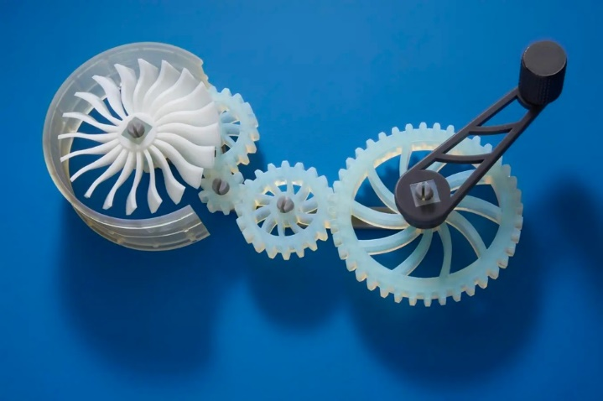

* The competition is open to individuals or teams with a passion for 3D modeling and printing.
* Participants of all skill levels are welcome.
* Each participant or team must submit their 3D model file(s) in a compatible format (e.g., STL, OBJ).
* Include a brief description of the design.
* Designs should adhere to the technical specifications of 3D printing, considering factors such as overhangs, wall thickness, and minimum feature size.
* Clearly label 3D model files with the participant's or team's name.
* Designs should be suitable for printing on a standard 3D printer (8cm X 8cm)
* Participants are expected to conduct themselves respectfully.
* Any form of cheating, harassment, or unsportsmanlike behavior may result in disqualification.
* The organizers reserve the right to modify the competition rules or schedule, if necessary, with timely communication to participants.

## 2.3 Robotics

## 2.3.1 Line Follower

**Description:** A Line Follower robot is a mobile machine that detects predefined lines on a surface underneath it by way of Infrared Sensors (IR) or else, that transmits data to a processor by specific transition buses. The processor then commands the driver in ways that let the robot follow the line.

Line Follower will be a knockout stage competition, and the winner will receive a cash prize.

Rules:

* Up to 5 members per team.
* The robot must be completely autonomous once the operator starts it.
* Maximum dimension of robot=30cm x 30cm x 30cm (LxWxH).
* There are no limits on the weight of the robot.
* LEGO kits as well as microcontroller-based robots are allowed
* In addition, there are no restrictions on the sensors used by the contestants. The robot can also touch the lines on the ground to detect them; however, it must not at any point damage the track. If the track gets damaged, then the robot will be disqualified.
* There are no restrictions in using readymade kits and modules, although the effort put into making the robot is taken into account while judging the robot by the jury
* 1 Point will be given on crossing every checkpoint
* If any robot stops working or if there is a technical fault, then it should be picked up by one of the team members and restarted from the start point, as preferred by the team members, this will be counted as a retry.
* A maximum of three retries are allowed, the minimum time will be counted.
* The jury may stop any robot at any time if they feel that it is performing or about to perform any action that is dangerous to people or setup.
* Teams will be given 1 minute for setting up the Robot at the start point.
* The robot can start at the instant when the start signal is given and a whistle is blown.
* Once the Robot moves, team members will not be allowed to touch the Robot or enter the Contest Arena.
* A team member will raise his hand to notify if he wants a retry
* Time will start once the start signal is given and the whistle is blown.
* The time duration for robots is 9 minutes. They can take 3 retries within this period.
* The track could be modified on the runtime to give ease to robots to complete the track.

**2.3.2. RC Car/Maze Solver**

A maze-solving robot is usually an autonomous robot designed to move in a maze and escape through it by following its walls. For college-level students, the challenge is redesigned using remote-controlled cars. The team that completes the maze in the shortest time is the winner. The competition will be held in the league and knockout stages, with the winner being awarded a cash prize.

**Rules**

• Maximum dimension of robot=30cm x 30cm x 30cm (LxWxH).

• There are no limits on the weight of the robot.

• Marks will be deducted if the robot collides with the wall.

• 10 minutes of setup time will be given before the start of the competition.

• There will be 3 retries in round 1.

• A robot that finishes the maze in the minimum time will be advanced.

• 15 minutes will be given to each team to run their robot in the track.

• Up to 5 members per team.

• The robot should not jump over, fly over, climb, scratch, cut, burn, mark, damage, or

destroy the walls of the maze.

• The maze design will be shared with the students 30 mins prior to the competition.

• The design of the maze can vary from competition to competition.

## 2.4. Truss Bridge Competition

**Rules**

1. Each team comprises 02 members.
2. A workshop shall be arranged at UCP to make you ready for the competition
3. You will choose your design and start working to make it a reality.
4. You have to bring the drawing of the chosen design on the competition day.
5. Material (Ice cream Sticks and Glue) will be supplied to you.

* It is a time-bound competition with a maximum time of 1 hr. for on-site fabrication.
* Already fabricated items will not be allowed.
* You must bring your calculators for calculation purposes.

**Evaluation Criteria**

* Your truss bridge must look like the drawing provided by you for the selected design.
* The weight of the Truss bridge will be measured (A).
* The finished bridge will be loaded at the center point of the span with external weights.
* The maximum value of the load that a truss bridge carries before fracture will be recorded (B).
* The ratio of weight carried to the weight of the bridge itself will be calculated (B/A).
* The team with the greatest B/A ratio will win the competition.

# 3.0. Exhibition and Shows

## 3.1. Science Cinema

**Description:** Science Cinema is a dynamic initiative designed to inspire participants of the Science & Engineering Festival by showcasing powerful stories of math, science, and sustainability. Through carefully selected movies and documentaries, the event seeks to highlight the profound contributions of historical figures and raise awareness about pressing environmental challenges in a visually captivating way. 

**Screenings:**  
Each day of the Science Fest will feature two screenings:

1. **A Non-Fiction Movie** – Showcasing the life and achievements of a renowned figure in mathematics or science.
2. **A Documentary on Environmental Sustainability** – Highlighting key issues, innovations, and solutions related to sustainability.

**Suggested Non-Fiction Movies:**

1. **A Beautiful Mind** – The story of John Nash and his groundbreaking work in game theory.
2. **The Man Who Knew Infinity** – A tribute to the genius of Srinivasa Ramanujan.
3. **The Theory of Everything** – The life and scientific contributions of Stephen Hawking.
4. **The Imitation Game** – Alan Turing’s pivotal role in cracking the Enigma code.
5. **Hidden Figures** – The inspiring story of African-American women mathematicians at NASA.
6. **October Sky** – A heartwarming tale of a young boy’s passion for rocket science.
7. **Contact** – A thought-provoking story about the pursuit of extraterrestrial life, based on Carl Sagan’s novel.

**Suggested Documentaries on Sustainability:**

1. **An Inconvenient Truth** – Al Gore’s groundbreaking documentary on climate change.
2. **Before the Flood** – Leonardo DiCaprio’s exploration of climate change impacts and solutions.
3. **The 11th Hour** – A compelling narrative on the environmental crises facing the planet.
4. **Our Planet** – A visually stunning Netflix series narrated by David Attenborough, focusing on biodiversity and conservation.
5. **Kiss the Ground** – Exploring the power of regenerative agriculture to combat climate change.
6. **A Life on Our Planet** – David Attenborough’s poignant reflection on humanity’s impact on Earth.

**Purpose**  
Science Cinema aims to inspire and engage audiences by showcasing the stories of extraordinary individuals in math and science alongside critical environmental themes. By combining entertainment with education, the event seeks to cultivate curiosity, inspire innovation, and promote sustainability.

Join us for an unforgettable cinematic journey that bridges the worlds of mathematics, science, and environmental awareness!

## 3.2. Science Circus

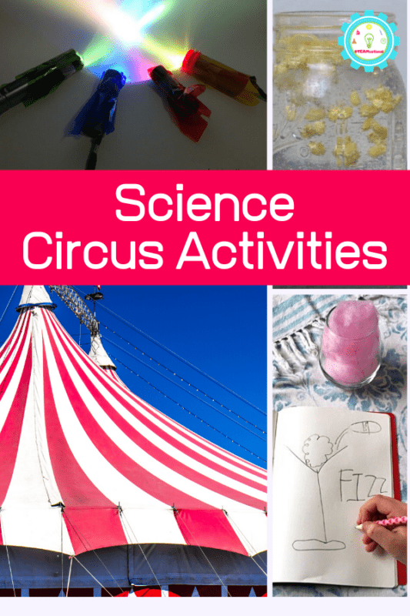“Science Circus" is a captivating fusion of art and science, where the boundaries between creativity and scientific exploration dissolve in a spectacular display of demonstrations and experiments.

The event unfolds as a vibrant and engaging circus, featuring captivating demonstrations of scientific experiments presented in a visually stunning and entertaining manner.

The performers, our skilled teachers and university students, bring scientific concepts to life through interactive and awe-inspiring displays. This immersive experience allows attendees to not only witness the magic of scientific principles but also actively participate in hands-on experiments that spark curiosity and learning.

For Science Fest ’25 , Science Circus will consists of three segments, directed by the three Department of FOST, namely Department Mathematics, Physics and Basic and Applied Chemistry.

The three segments are:

* Physics Fantasy
* Math Mania
* Chemicals Carnival

Total time= 60 minutes

Venue: Amphitheatre/ Auditorium UCP

Free for Participants

## 3.3. Nutrition camp

Nutrition camps play an important role in promoting awareness, knowledge and practical execution of healthy dietary habits. The purpose of the camp is to foster awareness about nutrition and its importance in maintaining good health. The camp aims to educate the students of the different institutions on healthy eating habits, a balanced diet, and the impact of nutrition on overall well-being. During the camp, you will learn all about how nutrition affects health, ways to eat to optimize your well-being and practical tips to help you eat for a healthier happier you.

* The Camp can provide the following services depending upon the participant’s involvement:
* Anthropometric Measurements (Weight, Height, BMI, W/H ratio)
* Biochemical assessment (Body fat measurement)
* Clinical Examination
* Dietary History (Food Frequency Questionnaire/24-hour recall)
* Counselling
* Diet plan
* The purpose of these evaluations is to understand the current health status of the students and
* Identify any potential nutritional deficiencies or health concerns.

## 3.4 Animal Taxidermy

Step into the fascinating world of Animal Taxidermy, an art form that preserves the natural beauty and intricacies of wildlife. Presented by the Zoology Department, this exhibition offers an in-depth look into the process of preserving animals for educational, scientific, and artistic purposes. Taxidermy allows us to study animals in their most detailed form, capturing their lifelike appearance for future generations.

In this exhibition, attendees will have the opportunity to explore a wide range of taxidermy specimens, including mammals, birds, reptiles, and more. Each display serves as a testament to the diversity of the animal kingdom, showcasing the skill and precision required to accurately preserve an animal's features while respecting its natural beauty. The exhibit not only highlights the craftsmanship involved but also emphasizes the scientific importance of preserving animals for study, conservation efforts, and the advancement of zoological research.

The Animal Taxidermy exhibition also aims to spark awareness about the ethical considerations and sustainability practices involved in the process. Through interactive displays and educational materials, visitors will gain insights into the role of taxidermy in wildlife conservation, the preservation of endangered species, and the broader ecological context.

Join us for an informative and thought-provoking experience as we celebrate the connection between science, art, and nature through the timeless practice of taxidermy.

## 3.5. Departmental Projects Display

The Departmental Project Display offers an immersive experience where students from 10 diverse departments showcase their final year projects, emphasizing both academic excellence and sustainable innovation. This event provides a unique platform for graduating students to present the culmination of their learning, creativity, and problem-solving skills, with a focus on addressing real-world challenges through sustainable practices.

Picture a vibrant exhibition space filled with stalls, each representing a different department. Here, students proudly display their final year projects, offering a firsthand look at how they are applying their academic knowledge to foster positive change. These projects span a wide array of fields—from cutting-edge computer science innovations to eco-friendly electrical engineering solutions—demonstrating how sustainability is being integrated into the heart of technological advancement.

To further enhance the exhibition experience, each student is given a dedicated stall to creatively present and explain their projects. These interactive hubs allow visitors to engage with the students’ work, gaining insights into the depth of research and innovation driving sustainable practices across various disciplines.

Beyond showcasing innovation, the Departmental Project Display serves as a gateway to future opportunities. Attendees will have the chance for career counseling, connecting with professionals and faculty who can offer valuable guidance on how sustainability is shaping career paths in science, technology, and engineering.

Ultimately, this event is a celebration of academic achievement, ingenuity, and the importance of sustainability in today’s world. The Departmental Project Display and Exhibition bridges the gap between theory and application, providing a glimpse into the impactful projects emerging from the minds of our graduating students—projects that aim to contribute to a more sustainable and innovative future.

# 4.0. Fun and Games

## 4.1. Jenga Jam

**Description:** Jenga is a classic wooden block stacking game where players take turns removing blocks from the tower and placing them on top, without causing the tower to fall. This is a one-on-one game. This will be a knockout session.

The winning participant of team 1 will be playing against winning participant of team 2 in the next round of game. and so on.

For example, if 8 teams are competing against each other, 4 winning teams will go to the semifinal round, then from those 4 teams, only 2 winning teams will go to the final round. In the end only 1 team will be the winner.

Rules:

* Build the tower by stacking the blocks in layers of three, alternating the blocks direction.
* Players take turns removing blocks from any level of the tower except the top two.
* Blocks can only be removed from the outside of the tower, not the inside.
* After removing a block, the player must place it on top of the tower
* If the tower falls, the player who caused it to fall loses.
* The game continues until a player successfully removes and places a block without causing the tower to fall.
* Proposed Venue: Building A/B lobby

Jenga is a great game for building decision-making skills and improving hand-to-eye coordination. The aim of this game is to teach kids the importance of being patient and how to be a good friend under pressure.

## 4.2. Brain Games

## 4.2.1 Mensa Connections/Ingenious

Ingenious is the English name for Einfach Genial (Simply Ingenious), a German abstract strategy board game designed by Reiner Knizia. It is known as Mensa Connections in the UK.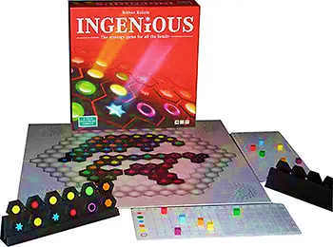 There are six colored symbols used in the game: red 12-pointed star, green circle, blue 6-pointed star, orange hexagon, yellow 24-pointed star, and purple ring.

Tiles are in the shape of two conjoined hexagons, with one of the colored symbols in each hexagon. There are six tiles for each two-color combination (e.g. red/orange) and five for each double (e.g. blue/blue). The combination of colors and symbols aids visually impaired players.

* The game can be played by two, three, or four players.
* Each player has a rack of six randomly chosen tiles which are concealed from the other players.
* The board is also made up of several hexagons, with the two outermost rings reserved for three- and four-player games respectively.
* Players take turns placing a tile on the board, scoring points by creating lines of identically colored hexes.
* On the first turn, each player must place a tile next to a different one of the six printed colored symbols on the board; thereafter players may place tiles on any free space.
* Scoring occurs from each of the two symbols on the tile. Counting outwards in a straight line from each of the five available faces of the two hexagons (the symbols on the tile itself are not counted), one point is scored in that tile's color for each identical symbol in an unbroken line. It is, therefore, possible to score points on two colors by placing a single tile.
* Each player's score is visible to everyone at all times.
* If a player reaches a score of 18 with any color, they declare 'Ingenious' and place another tile.
* If a player holds no tiles of their current lowest-scoring color, he/she may choose to swap his/her tiles. Their remaining tiles are shown to the other players, a full hand of six tiles is drawn, and the discarded ones are replaced in the bag.
* Every player must refresh his hand after every move by drawing a tile from the bag to bring it back up to a full hand of six.
* Any player scoring 18 on all six colors wins immediately. Otherwise, the game ends when no more pieces can be added to the board, at which time players check the color in which they have the fewest points. Whoever has the highest point value in their weakest colour is the winner of the game. In the case of ties, the second weakest colour is checked, and so on.

## 4.2.2. Rummy O-Rule

**Description:** Rummy-O is a [tile-based game](https://en.wikipedia.org/wiki/Tile-based_game) for 2 to 4 players, combining elements of the card game [rummy](https://en.wikipedia.org/wiki/Rummy) and [mahjong](https://en.wikipedia.org/wiki/Mahjong).

* The game is played with 106 numbered tiles. Tiles are numbered 1-13 in four different colors, each tile appearing twice; and there are two Jokers.
* All tiles are shuffled and placed on the table, face down. Each player takes one tile; the player who has the highest value, gets the first turn.
* Then these tiles are put back onto the table, and each player takes 14 tiles. The remaining tiles will form the **stock**.
* A player play his tiles in **melds** (groups) on the table, in two possible ways:

1. You play a run if you play three of more tiles of the same color, with numbers in sequence, like **456** or **910111213**.
2. You play a set if you play three or four tiles with the same number, in different colors, like All **777** or **1111** colors must be different, so this is ***not***valid: **444**.

* In each turn, you may take tiles that are already on the table and combine them with your own tiles to form new melds. At the end of your turn, however, all tiles on the table must be part of valid runs or sets again.
* It is not allowed to take tiles that were on the table at the start of your turn and put them back into your hand.
* Jokers are wildcard tiles that can represent any other tile. You play Jokers in the same way as you would play the tile they stand for, for example: **4*6** or **77*7**.
* You must replace the Joker with the matching tile, before you can use it anywhere else.In a set of three, the Joker can be replaced by any of the missing colors, e.g. in **22\***  you can release the Joker with either a **2** or a **2** .
* There is an additional restriction that the matching tile must come from your hand. You cannot replace the Joker by a tile that was already on the table.
* When you have played all the tiles you can (or want to), you say "Done!". Then the player at your left will get the turn.
* If you didn't play any of your tiles in your turn, then you have to draw another tile from the stock.
* Before you can play anything else in a game, you must play one or more new melds with a total of 30 or more. For example: **91011**, or **3333** **56\***. Jokers in these melds count as the tile they stand for.
* Only when you have played a total of 30 or more in new melds, you may add tiles to other melds or rearrange tiles that are on the table.
* Once you have played 30 or more in new melds, then in subsequent turns you can play anything you like.
* When you have played all your tiles in valid melds, so you have no tiles left, then you win the game.

## 4.2.3. Chinese Checkers

**Description:** Chinese checkers are a strategy board game of German origin that can be played by two, three, four, or six people, playing individually or with partners.

The aim is to race all one's pieces into the star corner on the opposite side of the board before the opponents do the same.

[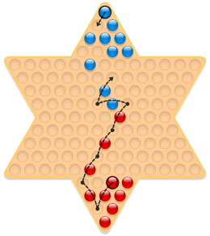](https://en.m.wikipedia.org/wiki/File:Chinese_checkers_moves.svg)The destination corner is called *home*.

* Each player has 10 pieces.
* Players take turns moving a single piece, either by moving one step in any direction to an adjacent space or by jumping in one or any number of available consecutive hops over other single pieces.
* A player may not combine hopping with a single-step move – a move consists of one or the other. In the diagram, Blue might move the topmost piece one space diagonally forward as shown.
* A *hop* consists of jumping over a single adjacent piece, either one's own or an opponent's, to the space directly beyond it in the same line of direction. Red might advance the indicated piece by a chain of seven hops in a single move.

## 4.2.4. Human Ludo

**Description:** Human Ludo is a game in which Humans play as Ludo Pawns. Human Ludo is a fun game best to utilize in your spare time. This game is proposed on the same rules and technique as Ludo.

* Four teams will be playing at a time
* Each team will maximum have 2 players.
* There will be two dice provided to the participants.
* If a team secures two sixes on the dice on a single turn, they will be allowed for another turn with the dice.
* Only one participant can come out of the prison at each six.
* If three consecutive sixes come for a team, then the turn for that team will be canceled and dice will be given to the next team.
* The participant can also enter the home even if he hasn’t killed a participant from another team.
* A team will win the match if one member of a team secures going home.
* The knockout system will be followed.

# Summary

|  |  |  |  |  |
| --- | --- | --- | --- | --- |
| Competition | Team size | Registration fee (per team/participants) | Prize money | What’s included in the fee |
| Brain Fest | 3 to 4 | 500 | 10,000 | Certificate of Participation |
| 3D Model Display | 1 to 3 | 500 | 10,000 | Certificate of Participation |
| Poster Competition | 1 to 3 | 500 | 10,000 | Certificate of Participation |
| The green equation expedition -Math Treasure Hunt | 2 to 3 | 500 | 10,000 | Hunt Kit  Certificate of Participation |
| Pet show competition | 1 to 3 | 500 | 10,000 | Certificate of Participation |
| Microbial Culture Art | 1 to 3 | 500 | 10,000 | Certificate of Participation |
| Robotics | 1 to 3 | 500 | 10,000 | Robotics kit  Workshop training |
| Robotics– Line Follower | 1 to 3 | 500 | 10,000 | Robotics kit  Workshop training |
| Robotics-RC Car/Maze Solver | 1 to 5 | 500 | 10,000 | Workshop training building material |
| Truss Design | 1 to 4 | 500 | 10,000 | Workshop training  Building material |
| 3D Printing | 1 to 3 | 500 | 10,000 | Certificate of Participation |
| Jenga Jam | 1 | 300 | 5,000 | Certificate of Participation |
| Brain games-Mensa connections/Ingenious | 1 to 4 | 300 | 5,000 | Certificate of Participation |
| Brain Games-Rummy O-Rule | 2 to 4 | 300 | 5,000 | Certificate of Participation |
| Brain Games- Chinese Checker | 1 | 300 | 5,000 | Certificate of Participation |